YORK COUNTY CORVETTE CLUB FUN SHOW

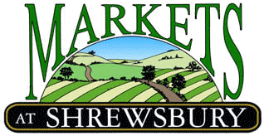
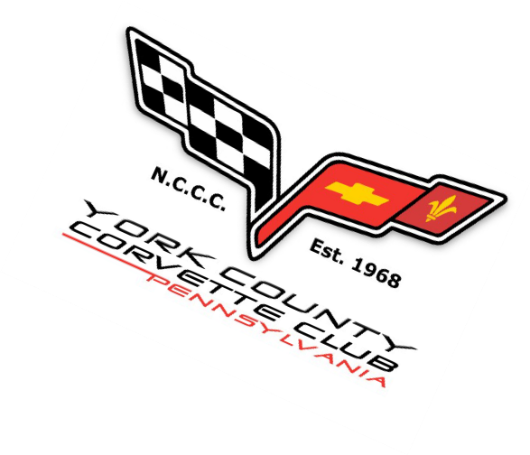
www.marketsatshrewsbury.com
12025 Susquehanna Trail Glen Rock, PA 17327
Off I-83 Between Exits 4 & 8

Saturday July 08, 2023
Registration 8 to 10 AM Awards 1:00 PM

NCCC SIX SANCTIONED FUN SHOW

30+ Prizes & Trophy's Including
People’s Choice, Interior, Mods, Paint, Most Unique, ….
Six NCCC Sanctioned Fun Show (NCCC membership not required)
*Farmers Market, Amish Gifts, PA Dutch Furniture & Crafts Stores*
Benefits the Chip Miller Foundation & York County Children's Advocacy Center

Show Chairs
  - Dave Kosko Cell (443) 271-3715
Per NCCC Policies, non NCCC participants are NOT covered by NCCC insurance.
Per NCCC Policies, NO Electric Vehicles, including Hybrids are permitted on the show field.
  - Chris Schaeffer (717) 880-2583

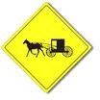
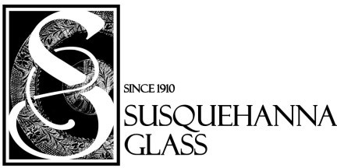
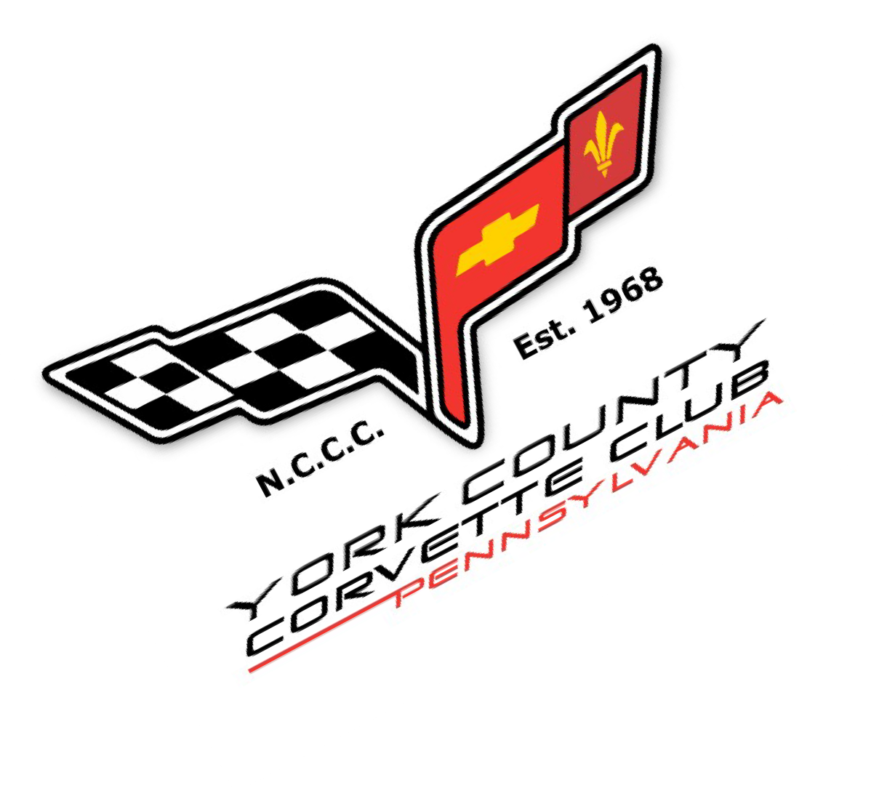
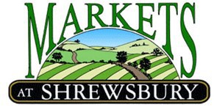
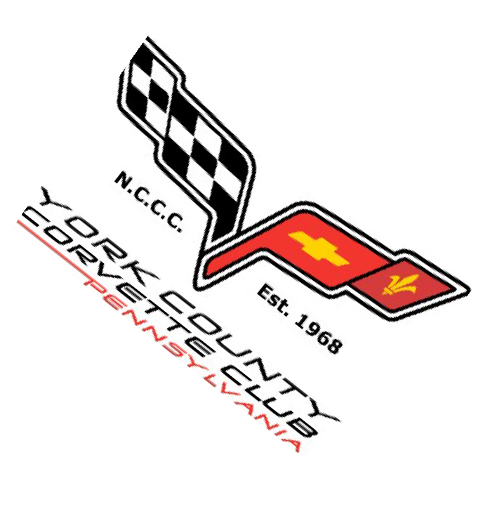
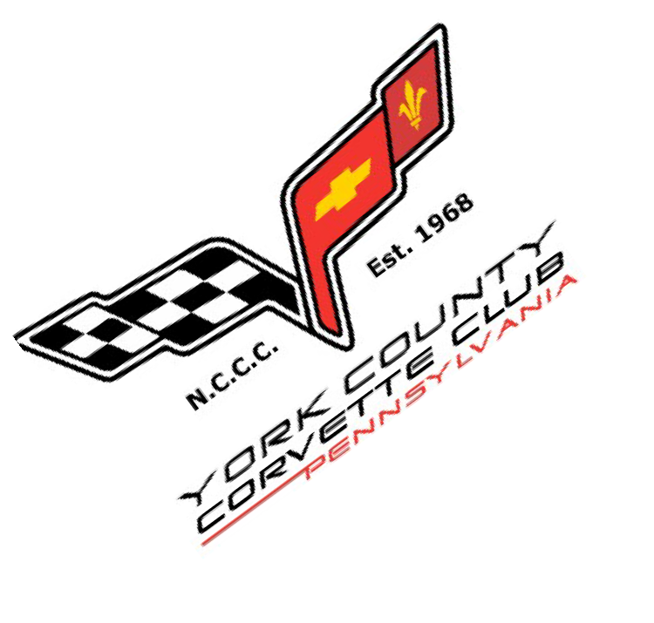

Saturday July 08, 2023
12025 Susquehanna Trail
Glen Rock, PA 17327 ~ Off I-83 Between Exits 4 & 8 Markets 717-235-6611
6 NCCC Sanctioned Fun Show (NCCC membership not required) Trophies for all Corvette Generations
This is a Rain or Shine Event
Driver: NCCC #

Co-Driver: NCCC #

NCCC Club: (Must Present NCCC Membership Card at Show Registration Table)
Generation: _ Model: Year: Color:

Address:
City: State: Zip
E-Mail: @ . Phone:

Mail Form with Payment to:
Registration 8:00 – 10:00 AM
Awards at 1:30 PM
David Kosko YCCC-Markets Show 2 3
50 Casey Lane
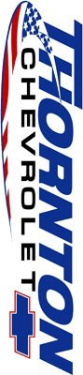
York, PA 17402
(443) 271-3715

Make Checks Payable to YCCC. Dash Plaques for the first 100 paid registrations.

Corvette NCCC 6 Sanction Event

NCCC 6 Sanction Show (Corvette) $ 35 $

=============================================
Pre-Registration Discount By 7/1 $ - 5.00
Total Entry Fee $

